TITOBI LABISI

JUNE 15 2022

There are some useful statements and formulas for your reference.

Logarithmic identities:

(power) log*b* (*xp*) = *p*log*b x*; (base change) 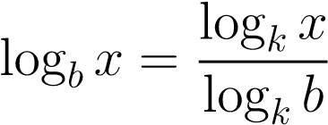*.*

A hierarchy of asymptotic growth:

1 ≪ log*k n* ≪ *nm* ≪ *an* ≪ *n*! ≪ *nn,*

where *k,m >* 0, *a >* 1.

For example,

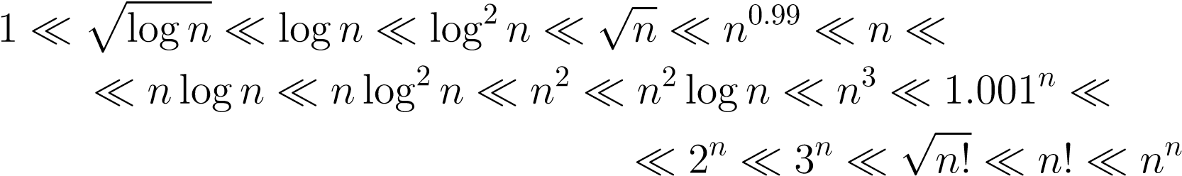*.*

Also, please, bear in mind that for any *a,b,c >* 1 and *d* ∈ R

log*b n* ≃ log*c n, an*+*d* ≃ *an.*

Stirling’s formula: 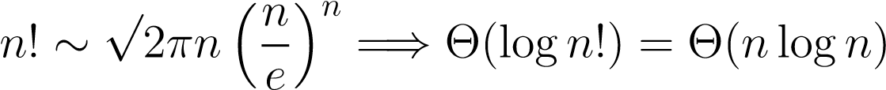.

Problem 1. [15 points] Give the best possible Big-Oh characterization for each of the following running time estimates, where *n* is the size of the input:

1. 2log*n* + 100000; O(logn) because the 2logn grows logarithmically with n, this means that its value increases just as n increases. Hence logarithmic growth is slower than linear growth. Ologn is the best characterization
2. *n*2 + 2*n*; O(n\*2) because the term n\*2 is quadratically growing with n, hence the value increases much faster
3. (2*n* + 1) + (2*n* − 1) + ··· + 5 + 3 + 1; O(n) because the expression is a summation of arithmetic series , which is function that grows linearly with n
4. 220 + 310, O(n\*2) because 2\*30 is growing exponentially with n, wjile 3\*10 also growns with n exponentially. Its O(n\*2) because exponential growth is faster than any other polynomial growth.
5. 1 + *n*2 + 2*n* + *n*!; O(n!) The term n!, the factorial of n, gorws factorially with n. Factorial growth is much faster than any polynomial growth hence why I chose O(n!)

Please, explain your answers.

Problem 2. [20 points] Which of the following functions



belong to

* *O*(*n*); logn^2 , 3 sqrt of n , log2^n
* • Θ(*n*); 2n +3, log n^2, 3 sqrt of n , log2^n
* Ω(*n*)? : 3^n, n^2 + n, logn^2 , 3 sqrt of n , log2^n